Software Architecture Document

Version 1.0

Revision History

|  |  |  |  |
| --- | --- | --- | --- |
| **Date** | **Version** | **Description** | **Author** |
| 25/12/2019 | 1.0 | Final Draft. | Phung Minh Nguyet |

Table of Contents

1. Introduction 2

1.1 Purpose 2

1.2 Scope 2

1.3 Definitions, Acronyms, and Abbreviations 2

1.4 References 2

1.5 Overview 2

2. Architectural Representation 2

3. Architectural Goals and Constraints 2

4. Use-Case View 2

4.1 Use-Case Realizations 2

5. Logical View 2

5.1 Overview 2

5.2 Architecturally Significant Design Packages 2

6. Process View 2

7. Deployment View 2

8. Implementation View 2

8.1 Overview 2

8.2 Layers 2

9. Data View (optional) 2

10. Size and Performance 2

11. Quality 2

Software Architecture Document

# Introduction

## Purpose

This document provides a comprehensive architectural overview of the system, using a number of different architectural views to depict different aspects of the system. It is intended to capture and convey the significant architectural decisions which have been made on the system.

## Scope

This document applies to the Computer Shop System which will be developed by CT Computer.

## Definitions, Acronyms, and Abbreviations

Admin: the person who develop the system and manage all in the computer shop.

Staff: who work for the shop.

Customer: a user who is not logged in the system.

## References

None

## Overview

In the following section, architectural design of the Computer Shop Management System is provided in detail. First, the primary software architecture of the system will be defined. Then, there are further discussion about the goals and constraints that will be imposed upon the quality of the final product, which including but not limited to security, distribution and reuse. In the precedence sections, the key views of the system are demonstrated to depict different aspects of the system. Lastly, criteria concerning with size, performance and quality of the system will be proposed.

# Architectural Representation

This documents presents the architectural as a series of mandatory views: Use-Case View, Logical View, Deployment View and Data View. These views are presented as Visual Paradigm Community Edition Models , StarUML and use the Unified Modeling Language (UML).

**Use-Case View**

* Audience: all the stakeholders of the system, including the end-users.
* Area: describes the set of scenarios and/or use cases that represent significant, central functionality to the system.
* Related artifacts: Use-Case Model, Analysis Model, Use-Case-Realization documents.

**Logical View**

* Audience: designers, programmers.
* Area: functional requirements: describes the design’s object model.
* Related artifacts: Design Model.

**Deployment View**

* Audience: deployment managers, system administrators.
* Area: topology: describes the mapping of the software onto the hardware and shows the systems distributed aspects.
* Related artifacts: Deployment Model.

**Data View**

* Audience: data specialists, database administrators.
* Area: persistence: describes the architecturally significant persistent elements in the data model.
* Related artifacts: Data Model.

# Architectural Goals and Constraints

There are some key requirements and system constraints that have a significant bearing on the architecture. They are:

* The Computer Shop Management System must be designed to fulfills all system requirements specified in requirements definition.
* The Computer Shop Management design must be structured to be robust, easy to change if and when functional requirements change.
* The Computer Shop Management System must be designed to allow the re-use of business logic across applications; therefore, the design separate the three components: model, view and controller.
* The separation of the three components: model, view and controller are also necessary to provide a convenient cooperation between different development teams.
* The Computer Shop Management System will run on a dedicated platform with access to a database.
* The Computer Shop Management website provides most of the content display. An interface to this system must be capable of handling large traffic volumes.

# Use-Case View

A description of the Use-Case View of the system architecture. The Use Case View is important input to the selection of the set of scenarios and/or use cases that are the focus of an iteration. It describes the set of scenarios and/or use cases that represent some significant, central functionality. It also describes the set of scenarios and/or use cases that have a substantial architectural coverage (that exercise many architectural elements) or that stress or illustrate a specific, delicate point of the architecture.

The significant use cases in this system are listed below:

* Log-in
* Log-out
* Search
* Feedback
* Create comment
* Delete comment
* View shopping cart
* Create Staff
* Update Staff
* Delete Staff
* Manage web
* Create order
* Delete order
* Create product
* Update product
* Delete product
* Create Category
* Update Category
* Delete Category
* Create news
* Update News
* Delete News
* Create Sub Category
* Update Sub Category
* Delete Sub Category
* Create customer feedback
* Delete customer feedback

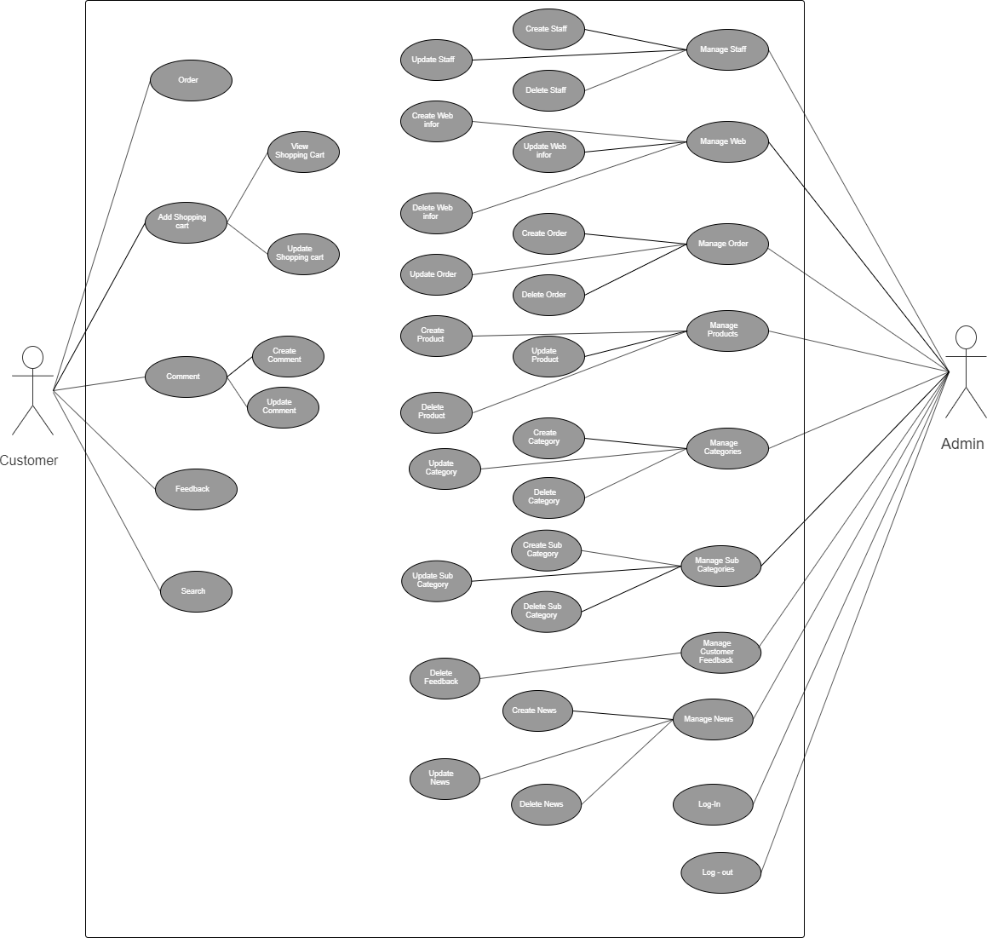

## Use-Case Realizations

1. Create Staff:

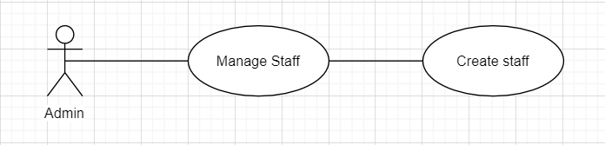

* Brief Description: Admin create staff’s information.
* Specification: See Use-Case-Realization Specification: Create Staff

1. Update Staff:

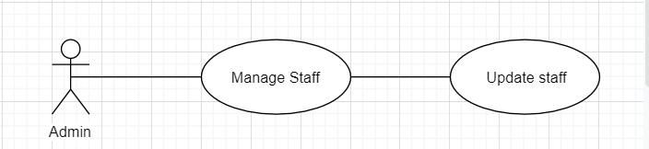

* Brief Description: Admin update staff’s information.
* Specification: See Use-Case-Realization Specification: Update Staff

1. Delete Staff:

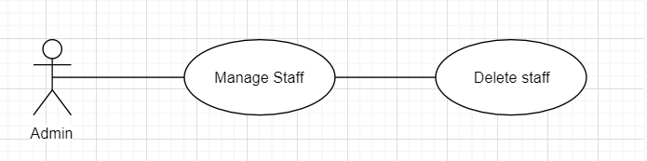

* Brief Description: Admin delete staff’s information.
* Specification: See Use-Case-Realization Specification: Delete Staff

1. Create Web:

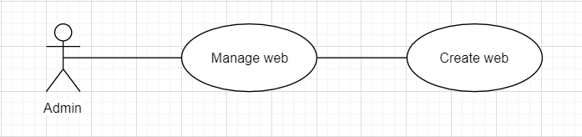

* Brief Description: Admin create web’s information.
* Specification: See Use-Case-Realization Specification: Create Web

1. Update Web :

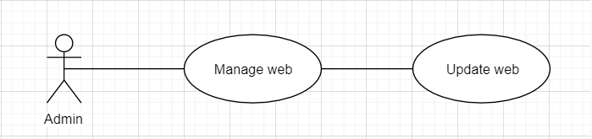

* Brief Description: Admin update web’s information.
* Specification: See Use-Case-Realization Specification: Update Web

1. Delete Web:

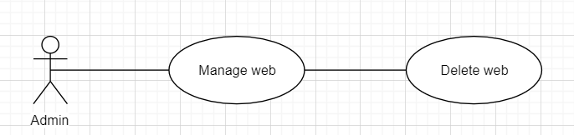

* Brief Description: Admin delete web’s information.
* Specification: See Use-Case-Realization Specification: Delete Web

1. Create order:

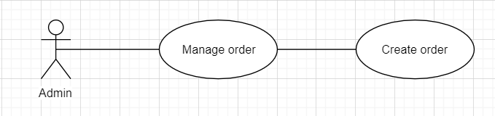

* Brief Description: Admin create order.
* Specification: See Use-Case-Realization Specification: Create order

1. Update order:

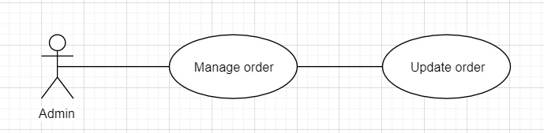

* Brief Description: Admin update order.
* Specification: See Use-Case-Realization Specification: Update order

1. Delete order:

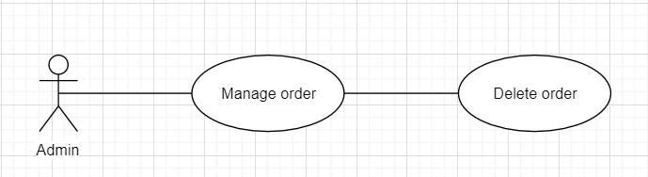

* Brief Description: Admin delete order.
* Specification: See Use-Case-Realization Specification: Delete order.

1. Create product:

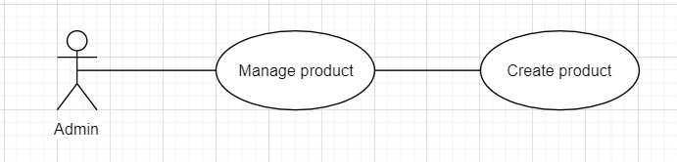

* Brief Description: Admin create product.
* Specification: See Use-Case-Realization Specification: Create product.

1. Update product:

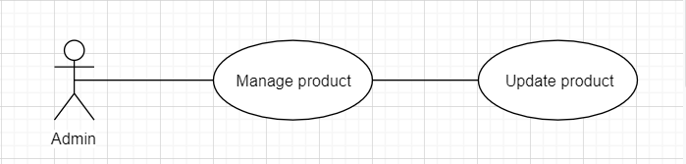

* Brief Description: Admin update product.
* Specification: See Use-Case-Realization Specification: Update product.

1. Delete product:

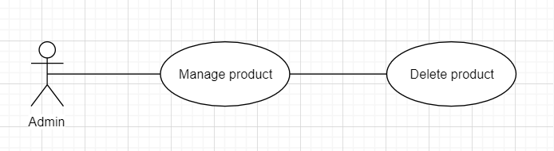

* Brief Description: Admin delete product.
* Specification: See Use-Case-Realization Specification: Delete product.

1. Create category:

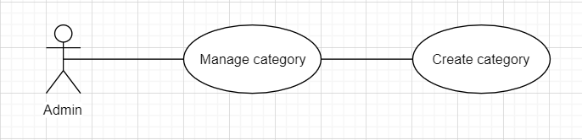

* Brief Description: Admin create category.
* Specification: See Use-Case-Realization Specification: Create category.

1. Update category:

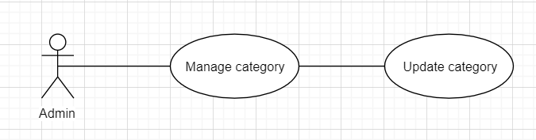

* Brief Description: Admin update category.
* Specification: See Use-Case-Realization Specification: Update category.

1. Delete category:

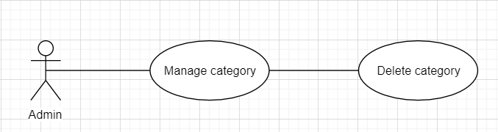

* Brief Description: Admin delete category.
* Specification: See Use-Case-Realization Specification: Delete category.

1. Create sub category:

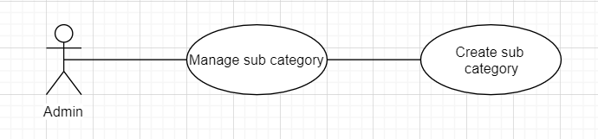

* Brief Description: Admin create sub category.
* Specification: See Use-Case-Realization Specification: Create sub category.

1. Update sub category:

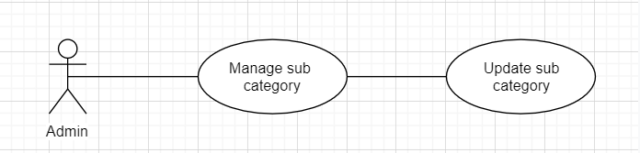

* Brief Description: Admin update sub category.
* Specification: See Use-Case-Realization Specification: Update sub category.

1. Delete sub category:

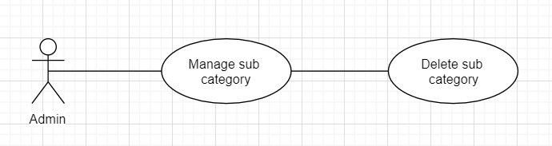

* Brief Description: Admin delete sub category.
* Specification: See Use-Case-Realization Specification: Delete sub category.

1. Create news:

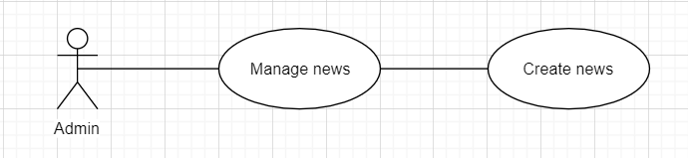

* Brief Description: Admin create news.
* Specification: See Use-Case-Realization Specification: Create news.

1. Update news:

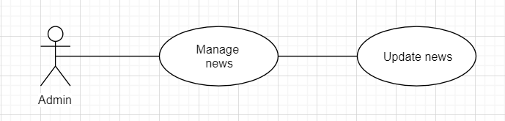

* Brief Description: Admin update news.
* Specification: See Use-Case-Realization Specification: Update news.

1. Delete news:

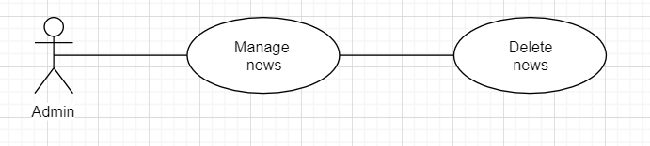

* Brief Description: Admin delete news.
* Specification: See Use-Case-Realization Specification: Delete news.

1. Delete customer’s feedback:

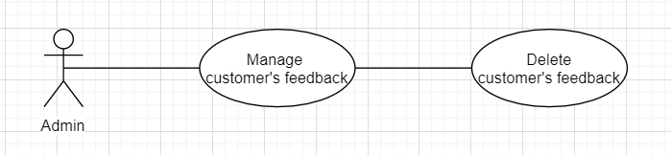

* Brief Description: Admin delete customer’s feedback.
* Specification: See Use-Case-Realization Specification: Delete customer’s feedback.

1. Log-in:

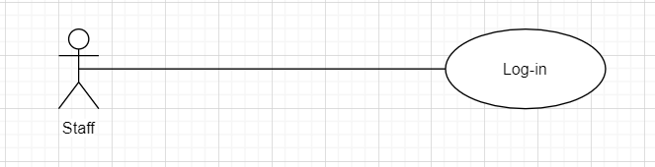

* Brief Description: Staff logging in to the system.
* Specification: See Use-Case-Realization Specification: Log-in

1. Log-out:

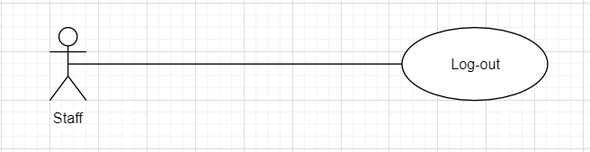

* Brief Description: Staff logging out to the system.
* Specification: See Use-Case-Realization Specification: Log-out.

1. Create order:

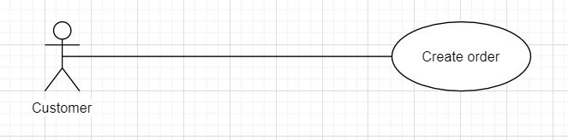

* Brief Description: Customer create the order.
* Specification: See Use-Case-Realization Specification: Create news.

1. Update shopping cart :

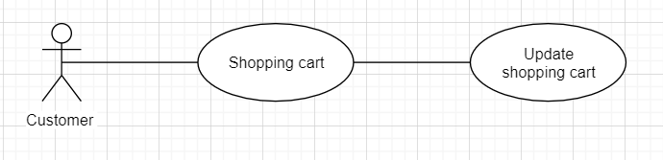

* Brief Description: Customer update shopping cart.
* Specification: See Use-Case-Realization Specification: Update shopping cart.

1. Delete comment:

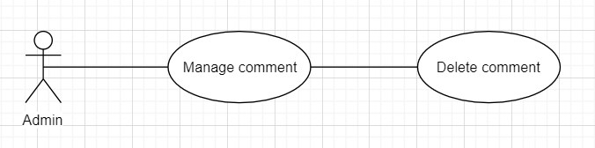

* Brief Description: Admin delete comment.
* Specification: See Use-Case-Realization Specification: Delete comment.

1. Create comment:

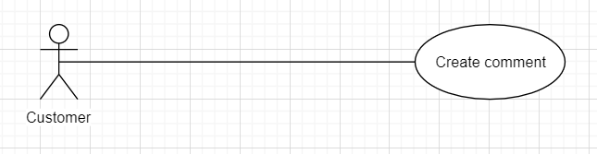

* Brief Description: Customer create comment.
* Specification: See Use-Case-Realization Specification: Create comment

1. Feedback:

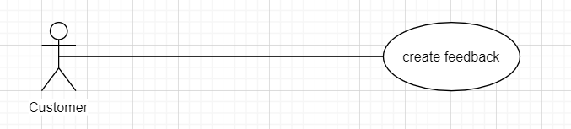

* Brief Description: Customer create the feedback to the shop.
* Specification: See Use-Case-Realization Specification: Feedback

1. Search:

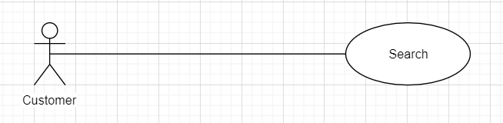

* Brief Description: Customer search the product.
* Specification: See Use-Case-Realization Specification: Search.

# Logical View

## Overview

A description of the logical view of the architecture. Describes the overall decomposition of the design model in terms of package hierarchy and layers.

The logical view of the Computer Shop System is comprised of 3 significant packages:

* Model: contains classes that directly manages the data, logic and rules of the Computer Shop System and displayed in the view.
* View: contains classes that generates output representation of information to the user based on changes in the model.
* Controller: contains classes that can send commands to the model to update the model’s state (e.g., add a new computer); it can also send commands to its associated view to change the view’s presentation of the model (e.g., scrolling through contract’s reviews).

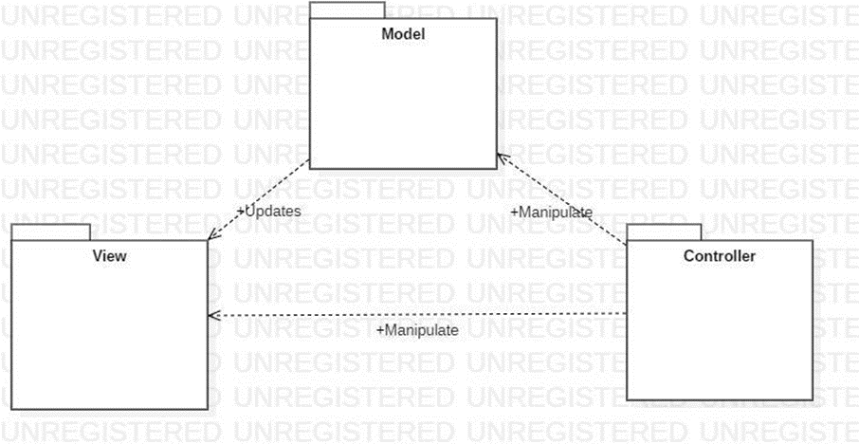

## Architecturally Significant Design Packages

### **Package Model**

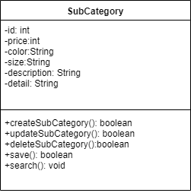 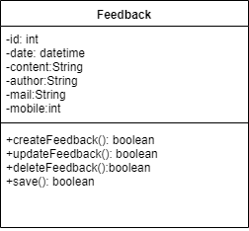

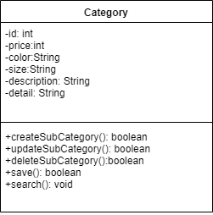 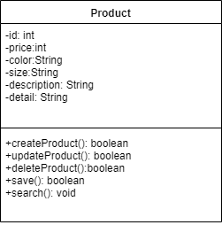

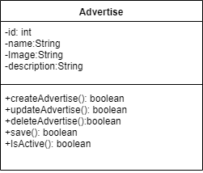 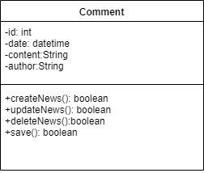 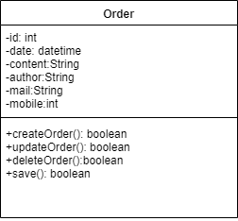

|  |  |
| --- | --- |
| **Name** | model |
| **Brief Description** | Contains classes that directly manages the data, logic and rules of |
| the Computer Shop Management System and displayed in the view. |
| **Classes** | Computer, Rating, Order, OrderLine, Payment. |

* + - * Class Categories:

|  |  |  |  |  |  |  |  |  |  |
| --- | --- | --- | --- | --- | --- | --- | --- | --- | --- |
| **Name** | User | | | | | | | | |
| **Brief Description** | Data model for user table in database. | | | | | | | | |
| **Attributes** | | | | | | | | | |
| **Name** | **Type** | **Access** | | **Mutable** | | **Optional** | **Length** | **Min** | **Max** |
| id | int | Private | | False | | False | 11 | 1 | N/A |
| name | String | Private | | True | | False | 250 | N/A | N/A |
| position | int | Private | | True | | False | 4 | N/A | N/A |
| **Operations** | | | | | | | | | |
| **Header** | **Return** | **Access** | **Scope** | | **Specification** | | | | |
| **Type** |
| Create() | Boolean | Public | Instance | | Create new Category | | |  |  |
| Return true if success. | | |  |  |
| Update() | Boolean | Public | Instance | | Update Category. Return true if success | | | | |
| Delete() | Boolean | Public | Instance | | Delete Category | | | | |
| Display() | Boolean | Public | Instance | | Display Categories list/information | | | |  |
| true if success. | |  |  |  |
| Save() | Boolean | Public | Instance | | Save Category in database | | |  |  |
| . |  |  |  |  |
| Search() | void | Private | Instance | | Search Category | | | | |

* + - * Class Sub Categories:

|  |  |  |  |  |  |  |  |  |  |
| --- | --- | --- | --- | --- | --- | --- | --- | --- | --- |
| **Name** | User | | | | | | | | |
| **Brief Description** | Data model for user table in database. | | | | | | | | |
| **Attributes** | | | | | | | | | |
| **Name** | **Type** | **Access** | | **Mutable** | | **Optional** | **Length** | **Min** | **Max** |
| id | int | Private | | False | | False | 11 | 1 | N/A |
| category_id | int | Private | | False | | False | 11 | 1 | N/A |
| name | String | Private | | True | | False | 250 | N/A | N/A |
| position | int | Private | | True | | False | 4 | N/A | N/A |
| **Operations** | | | | | | | | | |
| **Header** | **Return** | **Access** | **Scope** | | **Specification** | | | | |
| **Type** |
| Create() | boolean | Public | Instance | | Create Sub Category | | |  |  |
| Return true if success. | | |  |  |
| Update() | boolean | Public | Instance | | Update Sub Category. Return true if success | | | | |
| Delete() | boolean | Public | Instance | | Delete Sub Category | | | | |
| Display() | boolean | Public | Instance | | Display Sub Category list/information | | | |  |
| true if success. | |  |  |  |
| Save() | boolean | Public | Instance | | Save Sub Category in database | | |  |  |
| . |  |  |  |  |
| Search() | void | Private | Instance | | Search Sub Category | | | | |

* + - * Class product:

|  |  |  |  |  |  |  |  |  |  |
| --- | --- | --- | --- | --- | --- | --- | --- | --- | --- |
| **Name** | User | | | | | | | | |
| **Brief Description** | Data model for user table in database. | | | | | | | | |
| **Attributes** | | | | | | | | | |
| **Name** | **Type** | **Access** | | **Mutable** | | **Optional** | **Length** | **Min** | **Max** |
| id | int | Private | | False | | False | 11 | 1 | N/A |
| name | String | Private | | True | | False | 550 | N/A | N/A |
| CategoryId | int | Private | | False | | False | 11 | 1 | N/A |
| SubCategoryId | int | Private | | False | | False | 11 | 1 | N/A |
| typeId | int | Private | | False | | False | 11 | 1 | N/A |
| Price | int | Private | | False | | False | 11 | 1 | N/A |
| Color | String | Private | | True | | False | 250 | N/A | N/A |
| Material | String | Private | | True | | False | 250 | N/A | N/A |
| Size | String | Private | | True | | False | 20 | N/A | N/A |
| **Operations** | | | | | | | | | |
| **Header** | **Return** | **Access** | **Scope** | | **Specification** | | | | |
| **Type** |
| Create() | boolean | Public | Instance | | Create new product | | |  |  |
| Return true if success. | | |  |  |
| Update() | boolean | Public | Instance | | Update product. Return true if success | | | | |
| Delete() | boolean | Public | Instance | | Delete product | | | | |
| Display() | boolean | Public | Instance | | Display product list/information | | | |  |
| true if success. | |  |  |  |
| Save() | boolean | Public | Instance | | Save product in database | | |  |  |
| . |  |  |  |  |
| Search() | void | Private | Instance | | Search product | | | | |

* + - * Class feedback:

|  |  |  |  |  |  |  |  |  |  |
| --- | --- | --- | --- | --- | --- | --- | --- | --- | --- |
| **Name** | User | | | | | | | | |
| **Brief Description** | Data model for user table in database. | | | | | | | | |
| **Attributes** | | | | | | | | | |
| **Name** | **Type** | **Access** | | **Mutable** | | **Optional** | **Length** | **Min** | **Max** |
| id | int | Private | | False | | False | 11 | 1 | N/A |
| name | String | Private | | True | | False | 50 | N/A | N/A |
| mail | String | Private | | True | | False | 50 | N/A | N/A |
| mobile | String | Private | | True | | False | 20 | N/A | N/A |
| **Operations** | | | | | | | | | |
| **Header** | **Return** | **Access** | **Scope** | | **Specification** | | | | |
| **Type** |
| Create() | boolean | Public | Instance | | Create new feedback | | |  |  |
| Return true if success. | | |  |  |
| Update() | boolean | Public | Instance | | Update feedback .Return true if success | | | | |
| Delete() | boolean | Public | Instance | | Delete feedback | | | | |
| Display() | boolean | Public | Instance | | Display feedback list/information | | | |  |
| true if success. | |  |  |  |
| Save() | boolean | Public | Instance | | Save feedback in database | | |  |  |
| . |  |  |  |  |

* + - * Class advertise:

|  |  |  |  |  |  |  |  |  |  |
| --- | --- | --- | --- | --- | --- | --- | --- | --- | --- |
| **Name** | User | | | | | | | | |
| **Brief Description** | Data model for user table in database. | | | | | | | | |
| **Attributes** | | | | | | | | | |
| **Name** | **Type** | **Access** | | **Mutable** | | **Optional** | **Length** | **Min** | **Max** |
| id | int | Private | | False | | False | 11 | 1 | N/A |
| name | String | Private | | True | | False | 150 | N/A | N/A |
| description | String | Private | | True | | False | 250 | N/A | N/A |
| **Operations** | | | | | | | | | |
| **Header** | **Return** | **Access** | **Scope** | | **Specification** | | | | |
| **Type** |
| Create() | boolean | Public | Instance | | Create new advertise | | |  |  |
| Return true if success. | | |  |  |
| Update() | boolean | Public | Instance | | Update advertise. Return true if success | | | | |
| Delete() | boolean | Public | Instance | | Delete advertise | | | | |
| Display() | boolean | Public | Instance | | Display advertise list/information | | | |  |
| true if success. | |  |  |  |
| Save() | boolean | Public | Instance | | Save advertise in database | | |  |  |
| . |  |  |  |  |

* + - * Class Comment:

|  |  |  |  |  |  |  |  |  |  |
| --- | --- | --- | --- | --- | --- | --- | --- | --- | --- |
| **Name** | User | | | | | | | | |
| **Brief Description** | Data model for user table in database. | | | | | | | | |
| **Attributes** | | | | | | | | | |
| **Name** | **Type** | **Access** | | **Mutable** | | **Optional** | **Length** | **Min** | **Max** |
| id | int | Private | | False | | False | 11 | 1 | N/A |
| name | String | Private | | True | | False | 250 | N/A | N/A |
| position | int | Private | | True | | False | 4 | N/A | N/A |
| **Operations** | | | | | | | | | |
| **Header** | **Return** | **Access** | **Scope** | | **Specification** | | | | |
| **Type** |
| Create() | boolean | Public | Instance | | Create new Comment | | |  |  |
| Return true if success. | | |  |  |
| Update() | boolean | Public | Instance | | Update Comment. Return true if success | | | | |
| Delete() | boolean | Public | Instance | | Delete Comment | | | | |
| Display() | boolean | Public | Instance | | Display Comment list/information | | | |  |
| true if success. | |  |  |  |
| Save() | boolean | Public | Instance | | Save Comment in database | | |  |  |
| . |  |  |  |  |

* + - * Class order:

|  |  |  |  |  |  |  |  |  |  |
| --- | --- | --- | --- | --- | --- | --- | --- | --- | --- |
| **Name** | User | | | | | | | | |
| **Brief Description** | Data model for user table in database. | | | | | | | | |
| **Attributes** | | | | | | | | | |
| **Name** | **Type** | **Access** | | **Mutable** | | **Optional** | **Length** | **Min** | **Max** |
| id | int | Private | | False | | False | 11 | 1 | N/A |
| name | String | Private | | True | | False | 50 | N/A | N/A |
| address | String | Private | | True | | False | 200 | N/A | N/A |
| phone | String | Private | | True | | False | 20 | N/A | N/A |
| email | String | Private | | True | | False | 50 | N/A | N/A |
| **Operations** | | | | | | | | | |
| **Header** | **Return** | **Access** | **Scope** | | **Specification** | | | | |
| **Type** |
| Create() | boolean | Public | Instance | | Create new order | | |  |  |
| Return true if success. | | |  |  |
| Update() | boolean | Public | Instance | | Update order. Return true if success | | | | |
| Delete() | boolean | Public | Instance | | Delete order | | | | |
| Display() | boolean | Public | Instance | | Display order list/information | | | |  |
| true if success. | |  |  |  |
| Save() | boolean | Public | Instance | | Save order in database | | |  |  |
| . |  |  |  |  |

* + 1. ***Package View***

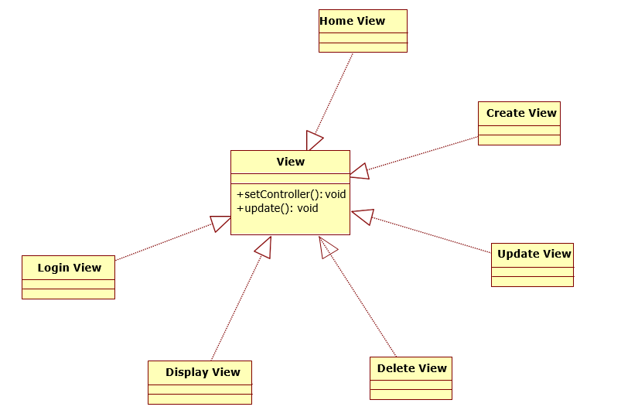

|  |  |
| --- | --- |
| **Name** | view |
| **Brief Description** | Contains classes that generates output representation of |
| Information to the user based on changes in the model. |
| **Interfaces** | View. |
| **Classes** | HomeView, LoginView, |
| DisplayView |
| CreateView, UpdateView, DeleteView, |

* + 1. **Package Controller**

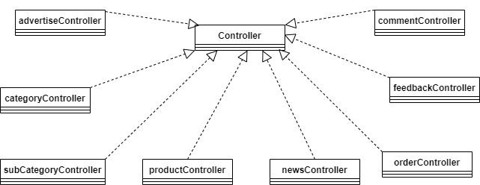

|  |  |
| --- | --- |
| **Name** | Controller |
| **Brief Description** | Controls the data flow into model object and updates the view whenever data changes |
| **Classes** | Controller, advertiseController, categoryController, OrderController, subCategoryController, productController, newsController,feedbackController,commentController |

* Class advertiseController

|  |  |  |  |  |  |  |  |
| --- | --- | --- | --- | --- | --- | --- | --- |
| **Name** | advertiseController | | | | | | |
| **Brief Description** | Class for handling operations related to advertise | | | | | | |
| **Attributes** | | | | | | | |
| **Name** | **Type** | **Access** | **Mutable** | **Optional** | **Length** | **Min** | **Max** |
| **Operations** | | | | | | | |
| **Header** | **Return Type** | **Access** | **Specification** | | | | |
| add | DBS | Public | Add advertise | | | | |
| update | DBS | Public | Update advertise | | | | |
| delete | DBS | Public | remove advertise | | | | |

* Class orderController

|  |  |  |  |  |  |  |  |
| --- | --- | --- | --- | --- | --- | --- | --- |
| **Name** | orderController | | | | | | |
| **Brief Description** | Class for handling operations related to order | | | | | | |
| **Attributes** | | | | | | | |
| **Name** | **Type** | **Access** | **Mutable** | **Optional** | **Length** | **Min** | **Max** |
| **Operations** | | | | | | | |
| **Header** | **Return Type** | **Access** | **Specification** | | | | |
| add | DBS | Public | Add order | | | | |
| update | DBS | Public | Update order | | | | |
| delete | DBS | Public | remove order | | | | |

* Class productController

|  |  |  |  |  |  |  |  |
| --- | --- | --- | --- | --- | --- | --- | --- |
| **Name** | productController | | | | | | |
| **Brief Description** | Class for handling operations related to product | | | | | | |
| **Attributes** | | | | | | | |
| **Name** | **Type** | **Access** | **Mutable** | **Optional** | **Length** | **Min** | **Max** |
| **Operations** | | | | | | | |
| **Header** | **Return Type** | **Access** | **Specification** | | | | |
| add | DBS | Public | Add product | | | | |
| update | DBS | Public | Update product | | | | |
| delete | DBS | Public | remove product | | | | |

* Class categoryController

|  |  |  |  |  |  |  |  |
| --- | --- | --- | --- | --- | --- | --- | --- |
| **Name** | categoryController | | | | | | |
| **Brief Description** | Class for handling operations related to category | | | | | | |
| **Attributes** | | | | | | | |
| **Name** | **Type** | **Access** | **Mutable** | **Optional** | **Length** | **Min** | **Max** |
| **Operations** | | | | | | | |
| **Header** | **Return Type** | **Access** | **Specification** | | | | |
| add | DBS | Public | Add category | | | | |
| update | DBS | Public | Update category | | | | |
| delete | DBS | Public | remove category | | | | |

* Class subCategoryController

|  |  |  |  |  |  |  |  |
| --- | --- | --- | --- | --- | --- | --- | --- |
| **Name** | subCategoryController | | | | | | |
| **Brief Description** | Class for handling operations related to subCategory | | | | | | |
| **Attributes** | | | | | | | |
| **Name** | **Type** | **Access** | **Mutable** | **Optional** | **Length** | **Min** | **Max** |
| **Operations** | | | | | | | |
| **Header** | **Return Type** | **Access** | **Specification** | | | | |
| add | DBS | Public | Add subCategory | | | | |
| update | DBS | Public | Update subCategory | | | | |
| delete | DBS | Public | remove subCategory | | | | |

* Class newsController

|  |  |  |  |  |  |  |  |
| --- | --- | --- | --- | --- | --- | --- | --- |
| **Name** | newsController | | | | | | |
| **Brief Description** | Class for handling operations related to news | | | | | | |
| **Attributes** | | | | | | | |
| **Name** | **Type** | **Access** | **Mutable** | **Optional** | **Length** | **Min** | **Max** |
| **Operations** | | | | | | | |
| **Header** | **Return Type** | **Access** | **Specification** | | | | |
| add | DBS | Public | Add news | | | | |
| update | DBS | Public | Update news | | | | |
| delete | DBS | Public | remove news | | | | |

* Class feedbackController

|  |  |  |  |  |  |  |  |
| --- | --- | --- | --- | --- | --- | --- | --- |
| **Name** | feedbackController | | | | | | |
| **Brief Description** | Class for handling operations related to feedback | | | | | | |
| **Attributes** | | | | | | | |
| **Name** | **Type** | **Access** | **Mutable** | **Optional** | **Length** | **Min** | **Max** |
| **Operations** | | | | | | | |
| **Header** | **Return Type** | **Access** | **Specification** | | | | |
| add | DBS | Public | Add feedback | | | | |
| update | DBS | Public | Update feedback | | | | |
| delete | DBS | Public | remove feedback | | | | |

* Class commentController

|  |  |  |  |  |  |  |  |
| --- | --- | --- | --- | --- | --- | --- | --- |
| **Name** | commentController | | | | | | |
| **Brief Description** | Class for handling operations related to comment | | | | | | |
| **Attributes** | | | | | | | |
| **Name** | **Type** | **Access** | **Mutable** | **Optional** | **Length** | **Min** | **Max** |
| **Operations** | | | | | | | |
| **Header** | **Return Type** | **Access** | **Specification** | | | | |
| add | DBS | Public | Add comment | | | | |
| delete | DBS | Public | remove comment | | | | |

# Process View

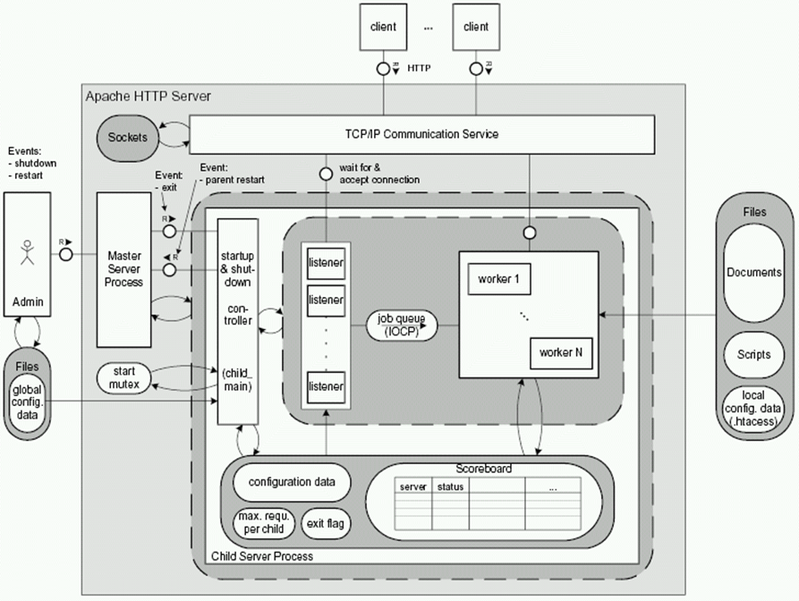

# Deployment View

This section describes one or more physical network (hardware) configurations on which the warehouse management system is deployed and run. The system is comprised of these mandatory physical nodes: one firewall (internal), a web server, a database server and a backup database server. The diagram below is the simplicity version of the Warehouse Management System deployment view.

1. **Implementation View** 
   1. **Overview**

* The Implementation view depicts the physical composition of the implementation in terms of Implementation Subsystems, and Implementation Elements (directories and files, including source code, data, and executable files). Usually, the layers of the Implementation view do fit the layering defined in the Logical view
  1. **Layers**
     1. Presentation Layer
* The Presentation layer contains all the components needed to allow interactions with an end-user. It encompasses the user interface
  + 1. Control Layer
* The Control layer contains all the components used to access the domain layer or directly the resource layer when this is appropriate
  + 1. Resource Layer
* The Resource layer contains the components needed to enable communication between the business tier and the enterprise information systems (Database, external services, ERP, etc…)
  + 1. Domain layer
* The Domain layer contains all the components related to the business logic. It gathers all the subsystems that meet the needs of a particular business domain. It also contains the business object model.
  + 1. Common Element Layer
* The Common Element layer contains the components re-used within several layers.

1. **Data View(Optional)**
2. **Size and Performance**

The major dimensioning characteristics of the software that impact the architecture and performance constraints:

* The system shall support up to 200 orders at the time.
* The system must perform all functions with minimal time delays.
* The system must also accurately save all information transactions.

1. **Quality**

The system architecture supports the quality requirements:

* In order to maintain the highest degree of system integrity, the system is capable of

ensuring that all information transitions are saved.

* Databases will be backed up on a daily basis in concern with safety implications.